* The number of labeled unrooted trees with n nodes is nn−2.
* The number of labeled rooted trees with n nodes is nn−1.
* Denote the number of unlabeled rooted trees with n nodes by an, then

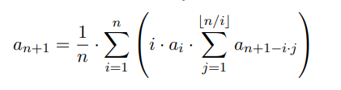

* Denote the number of unlabeled unrooted trees with n nodes by bn.

If n is odd number, then

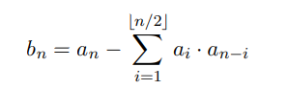

If n is even number, then

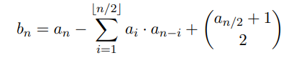

* The number of of labeled graphs 
* Denote the number of connected labeled graphs with n vertices as Cn, then

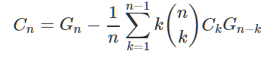

* The number of labeled graphs with k connected components.

We will compute D[i][j] - the number of labeled graphs with i vertices and j components - for each i≤n and j≤k.

